|  |  |  |
| --- | --- | --- |
|  |  | **LifeGuardian: A Smart Bracelet for Elderly**  **Shelena Soosay Nathan1*, Mohamad Adrian Bin Mohd Fuaad1, Qairel Qayyum Bin Muhamad Ridhuan1, Wan Muhammad Alif Firdaus Bin Wan Hanapi1**  Center for Diploma Studies, Universiti Tun Hussein Onn Malaysia,  Muar, Johor, 84600, MALAYSIA  DOI: https://doi.org/10.30880/mari.0000.00.00.000  Received 00 Month 2023; Accepted 01 Month 2023; Available online 02 Month 2023    **Abstract:** This study investigates the utilization of lifeguardian as a promising technology to monitor and enhance individuals' well-being. The research aims to achieve a comprehensive understanding of the main objectives, namely to assess the effectiveness of health bracelets in tracking vital signs and physical activity, to evaluate their impact on health outcomes, and to identify potential limitations and challenges. The study employs a mixed-methods approach, combining quantitative data analysis from a diverse sample of participants and qualitative interviews with adulth users. Results indicate that lifeguardian accurately measure heart rate, blood pressure, temperature,oxygen levels, valuable insights into individuals' overall health status. Moreover, wearing these bracelets for an extended period has been associated with improved physical activity levels and enhanced awareness of personal health. However, challenges related to accuracy and reliability of measurements, data privacy, and user adherence were identified. The discussion highlights the need for further research to address these limitations, as well as the importance of customization and personalization features in future bracelet designs. Overall, this study contributes to the growing body of knowledge on lifeguardian and offers insights for researchers, practitioners, and developers to enhance the effectiveness and user experience of these wearable devices.  **Keywords**: lifeguardian, bracelet, wearable device, sensors, health |

1. **Introduction**

In addition to the mentioned defects in current wearable smart bracelets, several health-related issues need to be addressed. These include the potential risks associated with undiagnosed health conditions, delayed medical interventions, insufficient monitoring capabilities, and inadequate health education [1]. Many health conditions can go unnoticed without regular monitoring, leading to serious consequences [1]. Lack of timely intervention can result in critical situations such as heart attacks or sudden cardiac arrests. In emergency situations, the lack of advanced data analysis and processing capabilities in wearable devices hinders accurate and timely alerts, affecting the ability to seek immediate medical help. Moreover, insufficient health education can lead to misinterpretation of health data and inappropriate actions. It's important to recognize that wearable smart bracelets should be viewed as complementary tools, not replacements for professional medical advice, and involving healthcare professionals in data interpretation and medical interventions is crucial.The next section will discuss the comparison of the project followed by the methodology used in the project. Section 3 will discuss the method of our project followed by results and discussion as well the as conclusion as the last section of this paper.

1. **Literature review**

Lifeguardian was developed to cater to the healthcare needs of older adults in an aging society [2]. It is a user-friendly wearable device that utilizes sensors such as a heart rate monitor, oxygen saturation monitor, heartbeat monitoring, and an emergency button. These sensors enable continuous health monitoring, early detection of health issues, enhance safety, and provide personalized health insights [3]. The bracelet empowers older adults by offering real-time data on vital signs, facilitating timely intervention, and ensuring peace of mind during emergencies. Overall, lifeguardian aims to improve the quality of life for older adults by integrating technology into their healthcare journey. This allows for ongoing assessment of health status. Secondly, the bracelet aids in the early detection of potential health issues by monitoring key indicators, enabling timely intervention and treatment. Additionally, the presence of the emergency button enhances wearer safety by enabling them to easily summon assistance during emergencies, ensuring peace of mind. Finally, the data collected by the sensors can be analyzed to provide personalized health insights and actionable recommendations, empowering wearers to make informed decisions to improve their well-being.

**Table 1: Differences between the existing projects**

|  |  |  |
| --- | --- | --- |
| Differences Project | Advantages | Disadvantages |
| MyBotic Durian UNO - Smart Patient Monitoring System [4] | Contains LCD display for displaying user health metrics. | Does not have an emergency button. |
|  | Includes SpO2 sensor for blood oxygen level monitoring, including BPM monitoring. | Large in size. |
|  | Includes LM35 Temperature Module, enabling body temperature tracking. | Lacks a battery to be fully portable and worn. |
| Pulse Oximeter! Measure Heart Rate and Oxygen Saturation using Max30102, Arduino and Oled Display [5] | Contains a similar LCD display to the MyBotic system. | Lacks a temperature sensor. |
|  | Tracks and measures BPM and SpO2 levels. | Push button can be seen as unnecessary and should've been used as an emergency button. |
|  | Includes a push button that acts as a display navigator. | Unable to be worn, lack of a proper strap. |
| Heart beat monitoring wrist band. Is it possible to make using MAX30102 module[6] | Comes with similar heartbeat sensing capabilities as other Arduino projects. | No SpO2 sensor for blood oxygen level monitoring. |
|  | Smaller LCD display that projects current wearer's readings. | Lack of an emergency button. |
|  | Smallest size footprint amongst the bunch. | Similar to the other Arduino projects, with no distinguishing feature. |

Table 1 shows that most of the project used similar items In the realm of Arduino projects, health monitoring systems have gained significant popularity due to their ability to track vital health metrics in an affordable and accessible manner. This to provides a comparative analysis of three such Arduino projects: MyBotic Durian UNO, MountDynamics Health Monitoring System, and Ut Go Health Monitoring Wristband. The analysis focuses on their advantages and disadvantages, enabling readers to make informed decisions when choosing a suitable health monitoring solution.

# Methodology

# The methodology that is used in this study is Agile methodology is an iterative and incremental approach to software development that prioritises adaptability, collaboration, and continuous improvement[7].Unlike traditional waterfall methods, agile methodologies emphasise customer collaboration, frequent feedback, and the delivery of working software in short development cycles called sprints. Agile projects are divided into phases, each with its specific objectives and deliverables.

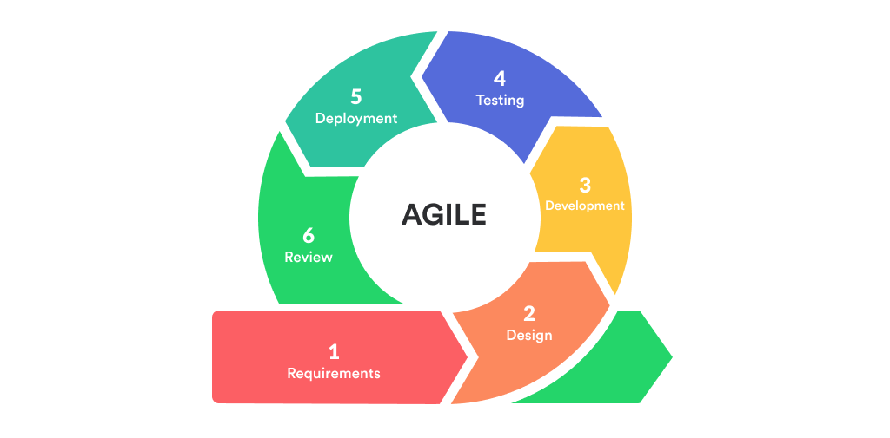

**Figure 1: Phase Agile Methodology**

3.1 Requirements

Requirements known as phase of methodology agile that for development of a health bracelet project. This is to revolutionized the wearble devices that have emerged as valuable tools for monitoring and improving personal health. This phase is to successful implementation of agile methodology throughout the project lifecycle

3.2 Design

During the design phase, requirements are obtained and the lifeguardian’s bracelet to find the appropriate business logic and methodology for the design. This phase also includes the design stage, which follows a top-down technical approach. Various diagrams, such as the context circuit diagram, and flowchart, are used in this scenario to describe how the lifeguardian’s bracelet would work, from receiving input to processing and providing the final output.

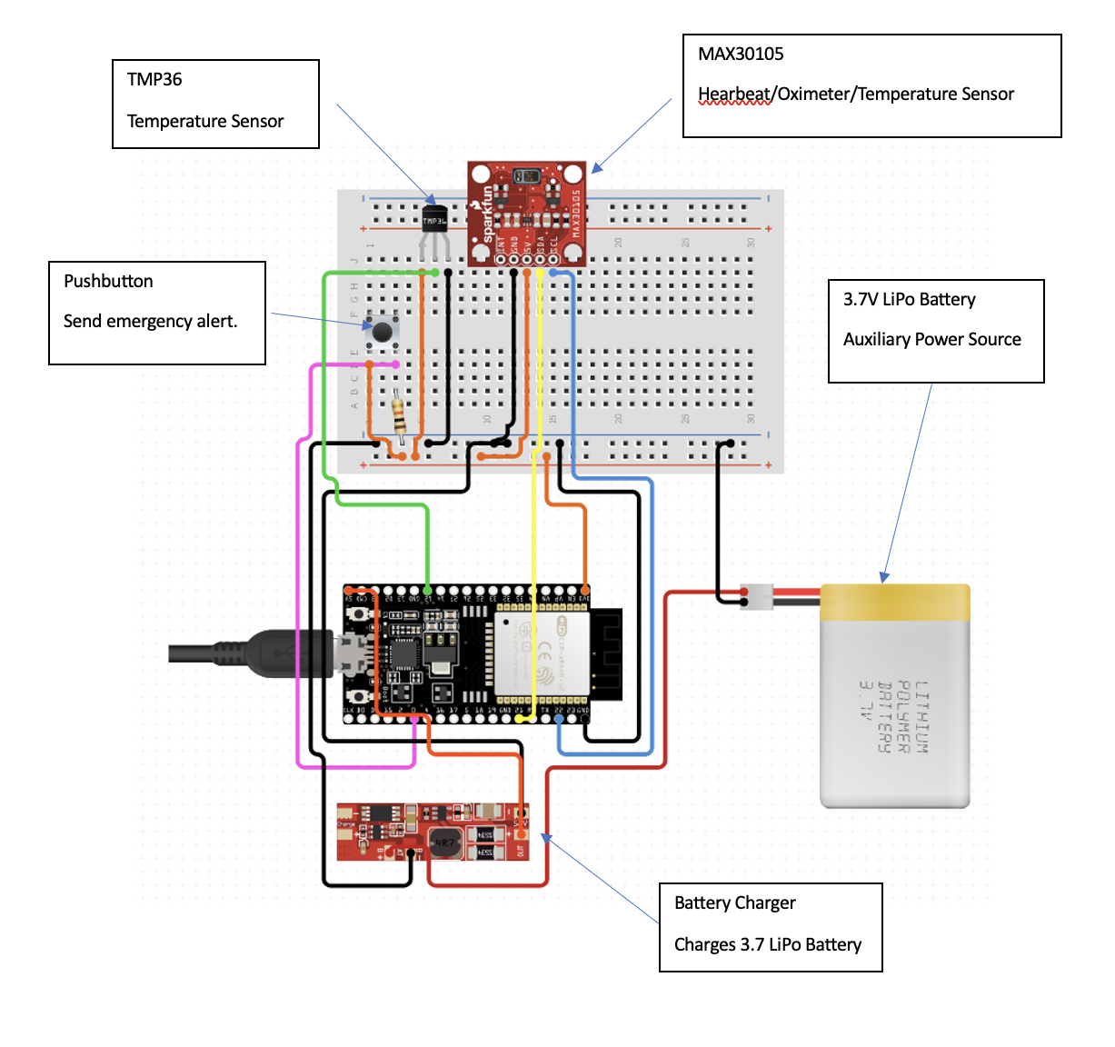 **Figure 2: Circuit Diagram**

Figure 2 shows function circuit diagram is a simplified graphical representation of how different components in a circuit are connected to perform a specific function. It shows the flow of electricity and the connections between the various components.

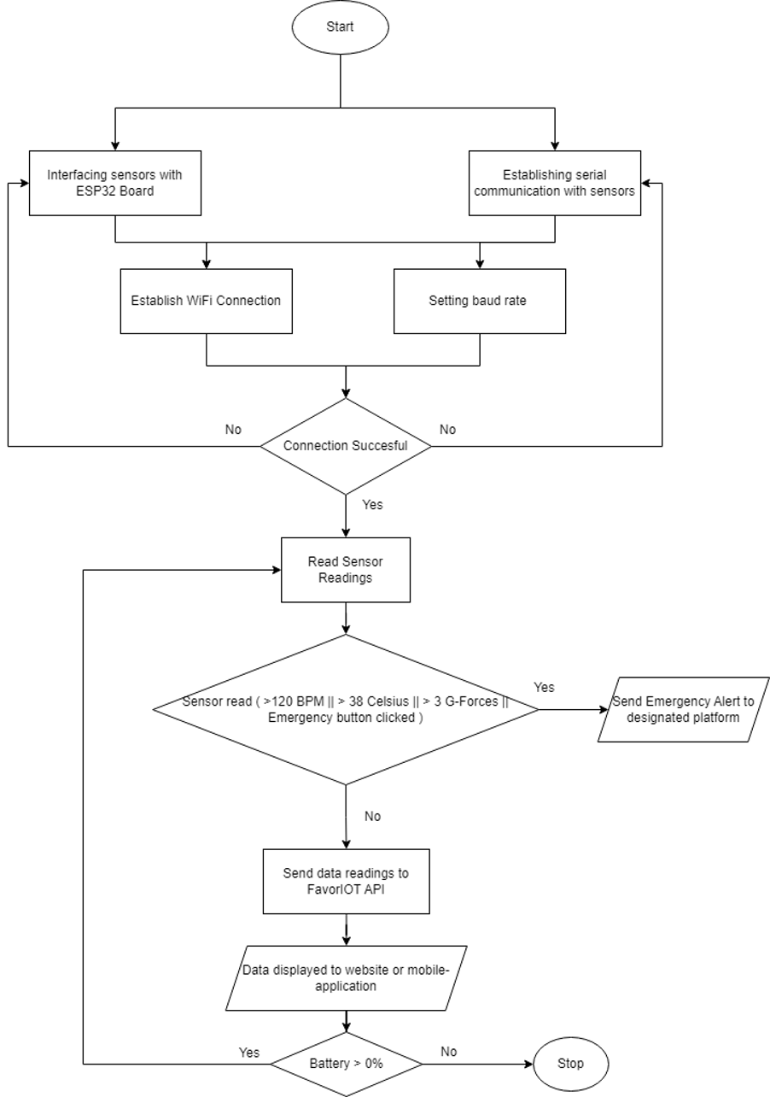

**Figure 3: Flowchart Diagram**

Figure 3 shows function flowchart is a visual representation of the steps or actions that need to be performed to achieve a specific task or function. It uses different symbols and shapes to illustrate the flow of activities in a logical sequence.

3.3 Development

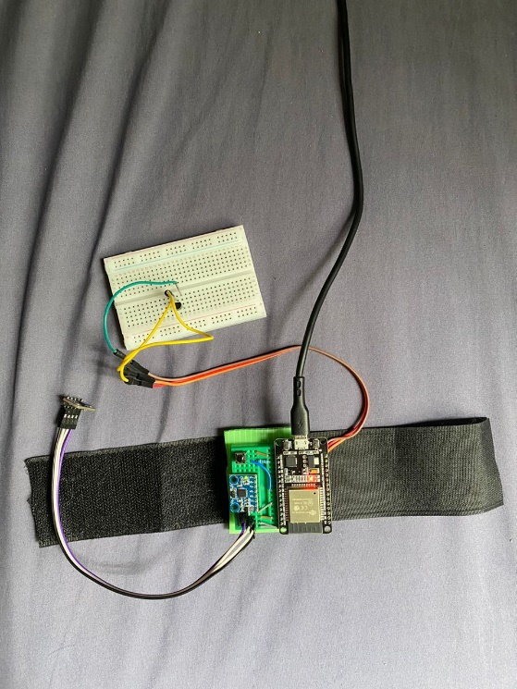

**Figure 4: Band**

After design, the project can begin development. All planning, component specifications, and design documents for the project's first iteration, including the temperature sensor, heartbeat sensor, emergency button, heart rate monitoring, impact and fall detection, and notification functionalities, have been coded. The lifeguardian’s bracelet will be implemented unit by unit, tested to assure functionality, and then integrated and combined into a cohesive, fully functional band.

3.4 Testing

The testing phase of lifeguardian development is crucial for ensuring its accuracy, reliability, and performance in measuring health data. This phase involves functional testing to validate the intended functionality of the bracelet, including its sensors and features such as temperature, heartbeat, emergency button, and notifications. Performance testing is conducted to ensure the accuracy and dependability of these sensors, comparing their readings with calibrated devices or medical standards. Compatibility testing is also important to ensure the bracelet works seamlessly across various platforms and devices, uncovering any issues related to data synchronization, connectivity, or performance. Thorough testing guarantees precise and trustworthy data, improving the overall user experience and effectiveness of health and fitness monitoring.

3.5 Deployment

In the Agile development of lifeguardian, deployment followed a collaborative and iterative approach. Continuous integration ensured regular integration of new features and components, while iterative deployment involved small, frequent releases based on user feedback and priorities. Cross-functional collaboration played a vital role in addressing integration challenges effectively. User acceptance testing validated integration and deployment, with feedback driving further improvements. Deployment pipelines automated the process, and continuous monitoring provided real-time data for ongoing enhancements. Through Agile methodology, lifeguardian achieved seamless integration and deployment, delivering a high-quality product that met user needs.

3.6 Review

Lifeguardian can be valuable tools for individuals looking to monitor their health. They provide convenient access to a range of health metrics and can help users make informed decisions about their well-being. However, it is important to consider the limitations and potential inaccuracies of these devices when interpreting the data they provide. Users should also be mindful of their specific needs and preferences when selecting a lifeguardian’s bracelet, considering factors such as accuracy, battery life, and desired features.

1. **Results and Discussion**

4.1 Results

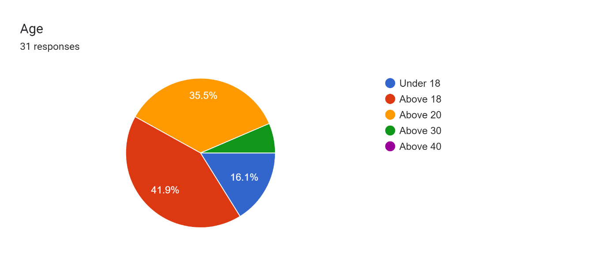

**Figure 5 : Age Respondents**

According to figure 5 , the data provided, individuals under the age of 18 account for 16.1% of the respondents who filled out the form. This indicates that there is a significant portion of the population in the younger age bracket. Furthermore, those above the age of 18 make up 41.9% of the participants, suggesting a larger representation of adults in the survey.

Additionally, when considering respondents above the age of 20, they comprise 35.5% of the total. This shows that there is a substantial number of individuals in their twenties who have taken part in the survey. Finally, the remaining percentage is allocated to those above the age of 30. Although the specific proportion is not provided, it can be inferred that the majority of respondents fall into this age group since it encompasses the leftover percentage.

Overall, based on the given data, it can be concluded that a significant majority of the individuals who filled out the form belong to the age group of adults. This suggests a potential focus on capturing the perspectives and insights of this specific demographic within the survey or study.

Forms response chart. Question title: Are you interested in a smart health bracelet with fall detection and emergency alert features?
. Number of responses: 31 responses.

**Figure 6 : Respondents Attract With Lifeguardian**

According to figure 6, the data collected from respondents, an overwhelming majority of 87.1% expressed their interest in a lifeguardian’s bracelet with fall detection and emergency alert features. This indicates a strong positive sentiment towards the proposed device, suggesting that the concept has generated considerable appeal among the participants. Conversely, 12.9% of respondents indicated their lack of interest in lifeguardian. Although this group represents a smaller portion of the sample, their feedback provides valuable insights into the market's diversity of preferences and needs. Overall, these statistics highlight the promising potential for a lifeguardian’s bracelet with fall detection and emergency alert features, as the majority of individuals surveyed expressed a keen interest in such a device.

4.2 Discussions

Usually, the accompanying commentaries follow the results section, providing more insight into the observations of the results.

1. **Conclusion**

In conclusion, the objective to develop a product that uses the IoT concept was achieved by producing a new model of wearable device which is able to give many benefits for people to stay healthy and encourage them. Through the testing, this project was proven to reach the expected outcome which fulfilled the objective of this project. As for the future improvements, a few recommendations such as adding few sensors and other features would be considered in the project to develop a better product for people stay healthy.

**Acknowledgement**

The authors would also like to thank the Centre for Diploma Studies, Universiti Tun Hussein Onn Malaysia for its support.

**References**

[1] M. A. Martínez-González, A. Gea, and M. Ruiz-Canela, “The Mediterranean Diet and Cardiovascular Health,” Circulation Research, vol. 124, no. 5, pp. 779–798, Mar. 2019, doi: 10.1161/circresaha.118.313348.

[2] Larnyo, E.; Dai, B.; Larnyo, A.; Nutakor, J.A.; Ampon-Wireko, S.; Nkrumah, E.N.K.; Appiah, R. Impact of Actual Use Behavior of Healthcare Wearable Devices on Quality of Life: A Cross-Sectional Survey of People with Dementia and Their Caregivers in Ghana. Healthcare 2022, 10, 275.

[3] D. Martinho, J. Carneiro, J. M. Corchado, and G. Marreiros, “A systematic review of gamification techniques applied to elderly care,” Artificial Intelligence Review, vol. 53, no. 7, pp. 4863–4901, Feb. 2020, doi: 10.1007/s10462-020-09809-6.

[4] Arduino IOT Smart Patient Monitoring system with BLYNK Durian UNO (Enhancement Of Arduino UNO),” Arduino IOT Smart Patient Monitoring system with BLYNK Durian UNO (Enhancement Of Arduino UNO). https://mybotic.com.my/arduino-iot-smart-patient-monitoring-system-with-blynk-durian-uno-enhancement-of-arduino-uno

[5] “Pulse Oximeter! Measure Heart Rate and Oxygen Saturation using Max30102, Arduino and Oled Display,” YouTube, Jun. 14, 2021. https://www.youtube.com/watch?v=W_3ljVlt7Sk

[6] “Heart beat monitoring wrist band. Is it possible to make using MAX30102 module ? | Ut Go,” YouTube, May 12, 2020. https://www.youtube.com/watch?v=qI_456UPf5Y

[7] V. Venkatesh, J. Y. L. Thong, F. K. Y. Chan, H. Hoehle, and K. Spohrer, “How agile software development methods reduce work exhaustion: Insights on role perceptions and organizational skills,” Information Systems Journal, vol. 30, no. 4, pp. 733–761, Mar. 2020, doi: 10.1111/isj.12282.